**GENERAL INTEGRATED SCIENCE**

**UNIT 4**

**Task 7 – Chemical Reactions, mixtures and solutions MARKING KEY**

NAME: ______________________________

DUE DATE: ______________________________ WEIGHTING: 10 %

TEACHER: ______________________________ MARK: ___ / 69 = _____ %

Important Information for Students

1. There are TWO sections in this test - Multiple Choice and Short Answer.
2. This is a closed-book assessment (no notes are allowed)
3. The time allowed to complete the test is 55 minutes.
4. Write your answers to the Multiple Choice section in the space provided. Circle only 1 answer.
5. Write your answers to the Short Answer section in space provided.

|  |  |  |
| --- | --- | --- |
| **Sections** | **Marks Allocation** | **Your Total** |
| **A - Multiple Choice** | 10 |  |
| **B - Short Answer** | 59 |  |
| **TOTAL** | 69 |  |

**Multichoice Questions  *(10 Marks)***

**Circle** the letter that represents the best answer from the choice of answers. Marks are not deducted for wrong answers.

1. Which of the following is NOT matter?
2. Humans
3. Air
4. Energy
5. Exhaust fumes
6. Compounds are combined ________ while mixtures are combined ________.
7. chemically, physically
8. physically, chemically
9. strongly, weakly
10. weakly, strongly
11. Which of the following numbers on the pH scale represents a strongly alkaline substance?
12. pH 1
13. pH 3
14. pH 8
15. pH 14
16. Which separation technique is based on the density of the substances in a mixture?
17. Sieving
18. Decantation
19. Chromatography
20. Filtration
21. Soaps and detergents are:
    1. fats
    2. emulsifiers
    3. acidic
    4. made of two hydrophobic ends
    5. made of two hydrophilic ends
22. Which of the following is true about acids?
23. They have a high pH (>7)
24. They are alkaline
25. They release hydroxide ions into water
26. They release hydrogen ions into water
27. A chemical reaction can only begin when
28. Enough activation energy is supplied to break the reactants bonds
29. Oxygen is present
30. Activation energy is removed
31. The chemical bonds in the reactants are still intact
32. You’re cooking a steak on a hot, dry grill. It starts to turn a delicious brown colour on the outside. What is the name of the chemical reaction that causes this?
33. Burning
34. Malliard
35. Caramelisation
36. Enzymatic Browning
37. Which separation method is used to separate a mixture based on the components density?
38. Distillation
39. Decantation
40. Chromatography
41. Evaporation
42. Sodium bicarbonate is reacted with citric acid in an **open** beaker. It produces carbon dioxide, water and a salt. After the reaction, the beaker will weigh:
    1. The same as the reactants
    2. More than the reactants
    3. It is impossible to test the weight of the products left in the beaker
    4. Less than the reactants

**Short Answer Section (58 marks)**

**Question 1. *(3 marks)***

List three observations that would reveal that a chemical reaction has occurred

Any three of: smell, sound, precipitate, colour change or temperature change.

**Question 2. *(2 marks)***

Explain the difference between a homogenous and a heterogeneous mixture

Some variation of: A homogenous mixture has a uniform distribution (1)

Some variation of: A heterogeneous mixture has a non-uniform distribution (1)

**Question 3.  *(6 marks)***

You are trying to make a hard candy, so you add a few tablespoons of sugar to a litre of cold tap water. After leaving your solution for a few days, you’re disappointed to find that it is still runny.

1. Explain two changes that you should make to your method to make hard candy *(4 marks)*

Add more sugar (1), which will make the solution more concentrated (1)

Increase the temperature (1) so that more solute can dissolve (1)

1. Circle the correct option. To make hard candy, the sugar-water solution must be *(1 mark*):

Dilute Saturated Supersaturated

1. Does the kind of solution from part b have more solute or solvent? Solute *(1 mark)*

**Question 4. *(2 marks)***

Describe the relationship between enzymes, activation energy and chemical reactions.

Enzymes lower activation energy

This speeds up the chemical reaction

**Question 5. *(4 marks)***

You make some sherbet by mixing citric acid, icing sugar and sodium bicarbonate.

1. What kind of acid reaction is occurring when you eat the sherbet? *(1 mark)*

Acid-Carbonate Reaction

1. What is the general word equation for this kind of reaction? *(1 mark)*

Acid + carbonate 🡪 a salt, water and carbon dioxide

1. Why does this reaction make your mouth feel cold? *(2 marks)*

Because it is an endothermic reaction (1), so it absorbs heat energy from your mouth (1)

**Question 6. (*6 marks)***

1. An unknown liquid was spilled in the kitchen. There are three containers on the floor; one is a water bottle, one is a strong acid used in cooking and one is a strong base used for cleaning. How would you accurately determine which substance has been spilt? *(4 marks)*

Using an indicator (1)

Some variation of: Water is neutral, so indicator would show 7 (1)

Some variation of: acid is acidic, so indicator would show low pH (1)

Some variation of: Base is alkaline, so indicator would show high pH (1)

1. Discuss why it is important to determine which substance was spilt in order to safely clean-up the mess *(2 marks)*

Some variation of: Different substances need to be cleaned in different ways to minimise harm (1)

Mention of acid/base neutralisation prior to cleaning (1)

**Question 7. *(3 marks)***

Match the following terms with the correct example

**Mayonnaise**

**Emulsion**

**Suspension**

**Homogenous Mixture**

**Salt Water**

**Salad Dressing**

**Question 8. *(5 marks)***

1. 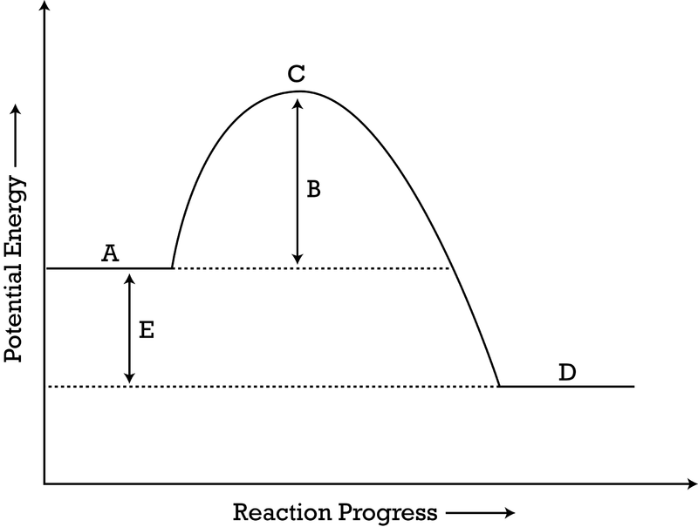On the following diagram, label the activation energy, the reactants energy level and the products energy level.

Products

Reactants

Activation Energy

1. Given that there is no scale on the Y-axis, **discuss** whether this reaction would be dangerous to be near *(3 marks).*

Depends on the magnitude of the scale (1)

The reaction is exothermic (1)

If big scale, then dangerous to be near because lots of energy released (1)

**Question 9. *(7 marks)***

Salami is made by compressing meat, adding bacteria and hanging the mixture in a dry environment to remove excess water.

1. Through what process is the water leaving the salami? *(1 mark )* Evaporation
2. Predict why the best-tasting and most expensive salamis have been left to hang for a longer period of time *(2 marks).*

Because the bacteria have more time to carry out fermentation (1)

Which means that more flavour has been added (1)

1. Bacteria is also used to make cheese. These bacteria undergo a form of respiration called fermentation, which is a chemical reaction that allows these bacteria to make energy. Name two other food or drinks that use fermentation during their production *(2 marks).*

Any two correct examples. E.g., bread, sauerkraut, kefir, kombucha, yoghurt, beer, wine, etc.

1. The term fermentation is based on a word that means ‘to bubble’. Given your understanding of chemical reactions, explain why fermentation might produce bubbles *(2 marks).*

Because the bacteria produced a gas (1)

Carbon Dioxide specifically stated (1)

**Question 10 *(5 marks)***

1. List two physical properties of orange juice *(2 marks*).

Any two correct properties. E.g, boiling point about 120 degrees, sweet tasting, sour tasting, liquid at room temperature, etc

1. Orange juice normally tastes sweet, but taste sour after brushing your teeth. Explain whether the properties of the orange juice change after you brush your teeth? *(2 marks)*

Properties don’t change (1) because there is no chemical reaction (1)

1. Suggest how the flavour of orange juice could change in this way *(1 mark).*

Chemical in toothpaste blocks sweet receptor

**Question 11 *(4 marks)***

In the food production process there are many chemical reactions that occur. Use the picture below to answer the following questions.

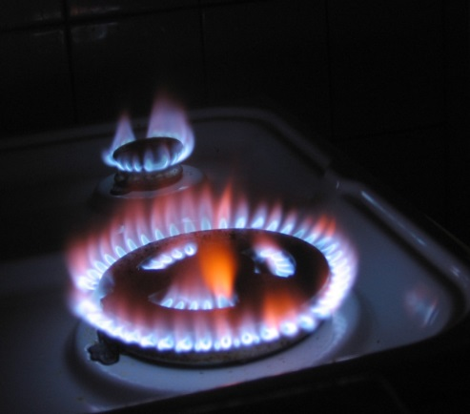

1. What reaction type is being represented in the picture of a gas stove top? *(1 mark)*

Combustion

1. Is this reaction endothermic or exothermic? *(1 mark)*

Exothermic

1. What are the reactants in this reaction? *(1 mark)*

Hydrocarbon and oxygen

1. What are the products in this reaction? *(1 mark)*

Carbon Dioxide, water and heat/energy

**Question 12 *(11 marks)***

You want to make a healthy soup for your family to try. You add red cabbage, water, and salt to a pot and allow them to cook for a few minutes. While you’re waiting, you remember that Apple Cider Vinegar is very healthy and decide to add some to the soup mixture. You accidentally add way too much, and to your shock, the soup turns red!

1. Briefly explain this colour change *(2 marks)*.

Red Cabbage is an indicator (1)

Turns red in the presence of an acid (1)

1. The vinegar has a pH of 2.8. Describe what *would* happen to the soups pH if you added a few tablespoons on sodium bicarbonate *(3 marks).*

Sodium bicarb is a base (1), so it would neutralise the acid (1) and make the pH more neutral (1)

You decide to start your soup again, but don’t want to waste the ingredients. Design a procedure that would enable you to remove the red cabbage, vinegar, and salt from the water. You will need to outline the separation technique you would use, and which chemical/physical property this technique is based on. Make sure that you use the scientific names for all procedures *(6 marks).*

Filtration (1 mark) to remove cabbage due to particle size (1)

Distillation (1) to remove vinegar based on boiling point (1)

Evaporation (1) to remove salt based on boiling point (1)